React-Bootstrap Form Component
React-Bootstrap is a front-end framework that was designed keeping react in mind. Form Component provides a way to make a form and take user input and then forward it to the server for further data processing. We can use the following approach in ReactJS to use the react-bootstrap Form Component.
Form Props:
- ref: It is used to forward the form-ref to the underlying element.
- as: It can be used as a custom element type for this component.
- inline: It is used to display the series of labels, buttons, etc on a single horizontal row.
- validated: It is used to mark a form as having been validated with true/false value.
- bsPrefix: It is an escape hatch for working with strongly customized bootstrap CSS.
Form.Label Props:
- ref: It is used to forward the form-ref to the underlying element.
- as: It can be used as a custom element type for this component.
- column: It is used to render the FormLabel as a <Col> component.
- htmlFor: It is used to Uses controlId from <FormGroup> if not explicitly specified.
- srOnly: It is used to hide the label visually.
- bsPrefix: It is an escape hatch for working with strongly customized bootstrap CSS.
Form.Group Props:
- ref: It is used to forward the form-ref to the underlying element.
- as: It can be used as a custom element type for this component.
- controlId: It is used to set the id on <FormControl> and htmlFor on <FormGroup.Label> component.
- bsPrefix: It is an escape hatch for working with strongly customized bootstrap CSS.
Form.Row Props:
- as: It can be used as a custom element type for this component.
- bsPrefix: It is an escape hatch for working with strongly customized bootstrap CSS.
Form.Text Props:
- ref: It is used to forward the formText ref to the underlying element.
- as: It can be used as a custom element type for this component.
- muted: It is used to add the text-muted class to it.
- bsPrefix: It is an escape hatch for working with strongly customized bootstrap CSS.
Form.Check Props:
- as: It can be used as a custom element type for this component.
- id: It is the normal HTML id attribute used for the identification.
- isInvalid: It is used to manually set the styling of the input as invalid.
- isStatic: It is used to add the position-static style to it.
- isValid: It is used to manually set the styling of the input as valid.
- type: It is used for the checkable types.
- bsPrefix: It is an escape hatch for working with strongly customized bootstrap CSS.
- bsCustomPrefix: For custom controls, it is used as a separate bsPrefix.
Form.Control Props:
- ref: It is used to forward the form-ref to the underlying element.
- as: It can be used as a custom element type for this component.
- custom: It is used to make use of Bootstrap’s custom form elements.
- disabled: It is used to make the control disabled.
- htmlSize: For the underlying element, it is used for its size attribute.
- id: It is used to make use of controlId from <FormGroup>
- isInvalid: For the control, it is used to add invalid validation styles.
- isValid: For the control, it is used to add valid validation styles.
- onChange: It is a callback function that is triggered on a change of value.
- plaintext: It is used to render the input as plain text.
- readOnly: It is used to make the control in the read-only state.
- size: It is used to denote the input size.
- type: It is used to denote the HTML input type for input.
- value: For underlying input, it is used for its value attribute.
- bsPrefix: It is an escape hatch for working with strongly customized bootstrap CSS.
- bsCustomPrefix: For custom controls, it is a separate bsPrefix.
Creating React Application And Installing Module:
Step 1: Create a React application using the following command:
npx create-react-app foldername
Step 2: After creating your project folder i.e. foldername, move to it using the following command:
cd foldername
Step 3: After creating the ReactJS application, Install the required module using the following command:
npm install react-bootstrap
npm install bootstrap
Project Structure: It will look like the following.
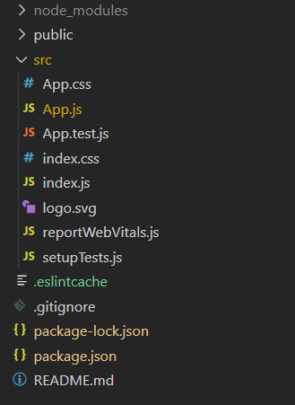
Project Structure
Example: Now write down the following code in the App.js file. Here, App is our default component where we have written our code.
Filename: App.js
- javascript
import React from 'react';
import 'bootstrap/dist/css/bootstrap.css';
import Form from 'react-bootstrap/Form';
import Button from 'react-bootstrap/Button';

export default function App() {
return (
<div style={{ display: 'block',
width: 700,
padding: 30 }}>
<h4>React-Bootstrap Form Component</h4>
<Form>
<Form.Group>
<Form.Label>Enter your full name:</Form.Label>
<Form.Control type="text"
placeholder="Enter your full name" />
</Form.Group>
<Form.Group>
<Form.Label>Enter your email address:</Form.Label>
<Form.Control type="email"
placeholder="Enter your your email address" />
</Form.Group>
<Form.Group>
<Form.Label>Enter your age:</Form.Label>
<Form.Control type="number" placeholder="Enter your age" />
</Form.Group>
<Button variant="primary" type="submit">
Click here to submit form
</Button>
</Form>
</div>
);
}
Step to Run Application: Run the application using the following command from the root directory of the project:
npm start
Output: Now open your browser and go to http://localhost:3000/, you will see the following output:
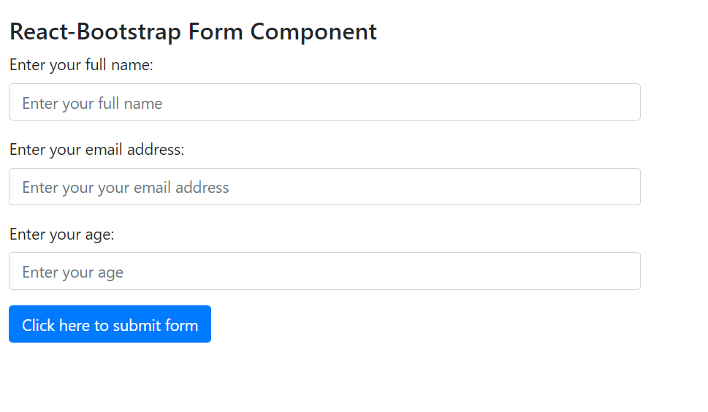
React-Bootstrap Modal Component
React-Bootstrap is a front-end framework that was designed keeping react in mind. Modal Component provides a way to add dialogs to our website for user notifications, displaying information, or to display completely custom information to the user. We can use the following approach in ReactJS to use the react-bootstrap Modal Component.
Modal Props:
- animation: It is used to add a fade animation when Modal is open and closed.
- autoFocus: When the modal is open, it is used to automatically shift focus to itself and replace it with the last focused element when it closes when this attribute is set to true.
- backdrop: It is used to include a backdrop component.
- backdropClassName: It is used to add an optional extra class name to .modal-backdrop
- centered: It is used to vertically center the Dialog which is open in the window.
- container: It is the container attribute, and it is of type any.
- aria-labelledby: It is the aria-labelledby attribute, and it is of type any.
- contentClassName: It is used to add an optional extra class name to .modal-content
- dialogAs: It is a Component type that helps in providing the modal content Markup.
- dialogClassName: It is the className for the dialog.
- enforceFocus: The modal will prevent focus from leaving the Modal while open when it is set to true.
- keyboard: When the escape key is pressed, it closes the modal.
- manager: In order to track and manage the state of open Modals, a ModalManager instance is used.
- onEnter: It is used to trigger a callback before the Modal transitions in.
- onEntered: It is used to trigger a callback after the Modal finishes transitioning in.
- onEntering: It is used to trigger a callback when Modal begins to transition in.
- onEscapeKeyDown: It is used to trigger a callback when the escape key is pressed.
- onExit: It is used to trigger a callback before the Modal transitions out.
- onExited: It is used to trigger a callback after the Modal finishes transitioning out.
- onExiting: It is used to trigger a callback when the Modal begins to transition out.
- onHide: It is used to trigger a callback when the header non-static backdrop or closeButton is clicked.
- onShow: It is used to trigger a callback when the Modal is opening.
- restoreFocus: It is used to restore focus to previously focused elements when modal is hidden.
- restoreFocusOptions: When restoreFocus is set to true, It is the set of option which are passed to focus function.
- scrollable: It is used in an overflow condition, and it allows scrolling the <Modal.Body> instead of the entire modal.
- show: It is used to show the modal.
- size: It is used to render the size of our modal.
- bsPrefix: It is an escape hatch for working with strongly customized bootstrap CSS.
Modal.Dialog Props:
- centered: It is used to indicate whether the component should be vertical centered or not.
- contentClassName: It is used to add the content class name for styling.
- scrollable: It is used to allow the scrolling of <Modal.Body> instead of the complete modal.
- size: It is used to render the size of our modal.
- bsPrefix: It is an escape hatch for working with strongly customized bootstrap CSS.
Modal.Header Props:
- closeButton: It is used to specify whether the modal should have a close button or not.
- closeLabel: It is used to provide an accessible label for the close button.
- onHide: It is a callback that is trigger when the close button is clicked.
- bsPrefix: It is an escape hatch for working with strongly customized bootstrap CSS.
Modal.Title Props:
- as: It can be used as a custom element type for this component.
- bsPrefix: It is an escape hatch for working with strongly customized bootstrap CSS.
Modal.Body Props:
- as: It can be used as a custom element type for this component.
- bsPrefix: It is an escape hatch for working with strongly customized bootstrap CSS.
Modal.Footer Props:
- as: It can be used as a custom element type for this component.
- bsPrefix: It is an escape hatch for working with strongly customized bootstrap CSS.
Creating React Application And Installing Module:
- Step 1: Create a React application using the following command:
npx create-react-app foldername
- Step 2: After creating your project folder i.e. foldername, move to it using the following command:
cd foldername
- Step 3: After creating the ReactJS application, Install the required module using the following command:
- npm install react-bootstrap
npm install bootstrap
Project Structure: It will look like the following.
Project Structure
Example: Now write down the following code in the App.js file. Here, App is our default component where we have written our code.
- App.js
import React from 'react';
import 'bootstrap/dist/css/bootstrap.css';
import Modal from 'react-bootstrap/Modal';
import Button from 'react-bootstrap/Button';

export default function App() {
return (
<div style={{ display: 'block',
width: 700,
padding: 30 }}>
<h4>React-Bootstrap Modal Component</h4>
<Modal.Dialog>
<Modal.Header closeButton>
<Modal.Title>
Sample Modal Heading
</Modal.Title>
</Modal.Header>
<Modal.Body>
<p>
This is the sample text for our Modal
</p>
</Modal.Body>
<Modal.Footer>
<Button variant="primary">
Save changes
</Button>
<Button variant="secondary">
Close
</Button>
</Modal.Footer>
</Modal.Dialog>
</div>
);
}
Step to Run Application: Run the application using the following command from the root directory of the project:
npm start
Output: Now open your browser and go to http://localhost:3000/, you will see the following output:
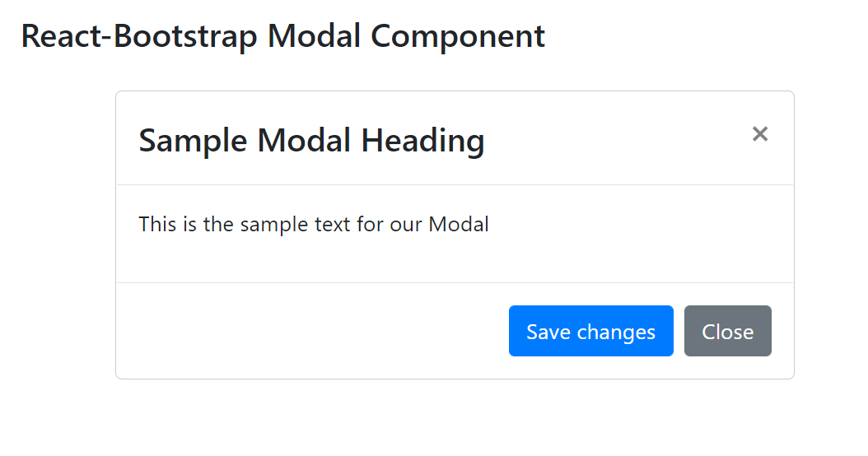
React-Bootstrap Tables Component
React-Bootstrap is a front-end framework that was designed keeping react in mind. Bootstrap was re-built and revamped for React, hence it is known as React-Bootstrap.
Tables in react-bootstrap come with predefined style classes which are both responsive and reliable.
Table props:
- bordered: Adds borders on all sides of the tables and cells.
- borderless: Removes borders on all sides including table header.
- variant: It is used to invert the colors of the table from dark to light and vice versa.
- size: It is used to set the size of the table. When we set it as ‘sm’ the cell padding is reduced by half.
- bsPrefix: It is an escape hatch for working with strongly customized bootstrap CSS.
Creating React Application And Installing Module:
Step 1: Create a React application using the following command:
npx create-react-app foldername
Step 2: After creating your project folder i.e. foldername, move to it using the following command:
cd foldername
Step 3: After creating the ReactJS application, Install the required modules using the following command:
npm install react-bootstrap bootstrap
Step 4: Add the below line in index.js file:
import 'bootstrap/dist/css/bootstrap.css';
Project Structure: It will look like the following.
Example: Now write down the following code in the App.js file. Here, App is our default component where we have written our code.
Filename: App.js
- Javascript
import React from 'react';
import Table from 'react-bootstrap/Table'

export default function TableExample() {
return (
<>

<h3>Default Variant Small Size Theme Table</h3>

<Table stripped bordered hover size="sm">
<thead>
<tr>
<th width="170">Student Name</th>
<th width="170">Reg.no</th>
<th width="170">Course</th>
<th width="870">City Name</th>
<th width="1950">Percentage</th>

</tr>
</thead>
<tbody>
<tr>
<td>Rakesh</td>
<td>1123</td>
<td>CSE</td>
<td>Mumbai</td>
<td>86.9%</td>

</tr>
<tr>
<td>Jackson</td>
<td>1124</td>
<td>ECE</td>
<td>Hyderabad</td>
<td>72.4%</td>

</tr>
<tr>
<td>Keshav</td>
<td>1124</td>
<td>CSE</td>
<td>Chennai</td>
<td>88%</td>

</tr>
<tr>
<td>Neilesh Jain</td>
<td>1125</td>
<td>EEE</td>
<td>Gwalior</td>
<td>66.9%</td>

</tr>
<tr>
<td>Akbar sheikh</td>
<td>1126</td>
<td>Mechanical</td>
<td>Indore</td>
<td>96.5%</td>

</tr>
<tr>
<td>Sarita</td>
<td>1127</td>
<td>CSE</td>
<td>Delhi</td>
<td>96.9%</td>

</tr>

</tbody>
</Table>

<h3>Dark Variant Small Size Table</h3>

<Table stripped bordered hover variant="dark" size="sm">
<thead>
<tr>
<th width="170">Student Name</th>
<th width="170">Reg.no</th>
<th width="170">Course</th>
<th width="870">City Name</th>
<th width="1950">Percentage</th>

</tr>
</thead>
<tbody>
<tr>
<td>Rakesh</td>
<td>1123</td>
<td>CSE</td>
<td>Mumbai</td>
<td>86.9%</td>

</tr>
<tr>
<td>Jackson</td>
<td>1124</td>
<td>ECE</td>
<td>Hyderabad</td>
<td>72.4%</td>

</tr>
<tr>
<td>Keshav</td>
<td>1124</td>
<td>CSE</td>
<td>Chennai</td>
<td>88%</td>

</tr>
<tr>
<td>Neilesh Jain</td>
<td>1125</td>
<td>EEE</td>
<td>Gwalior</td>
<td>66.9%</td>

</tr>
<tr>
<td>Akbar sheikh</td>
<td>1126</td>
<td>Mechanical</td>
<td>Indore</td>
<td>96.5%</td>

</tr>
<tr>
<td>Sarita</td>
<td>1127</td>
<td>CSE</td>
<td>Delhi</td>
<td>96.9%</td>

</tr>

</tbody>
</Table>
</>
);
}
Step to Run Application: Run the application using the following command from the root directory of the project:
npm start
Output: Now open your browser and go to http://localhost:3000/, you will see the following output.
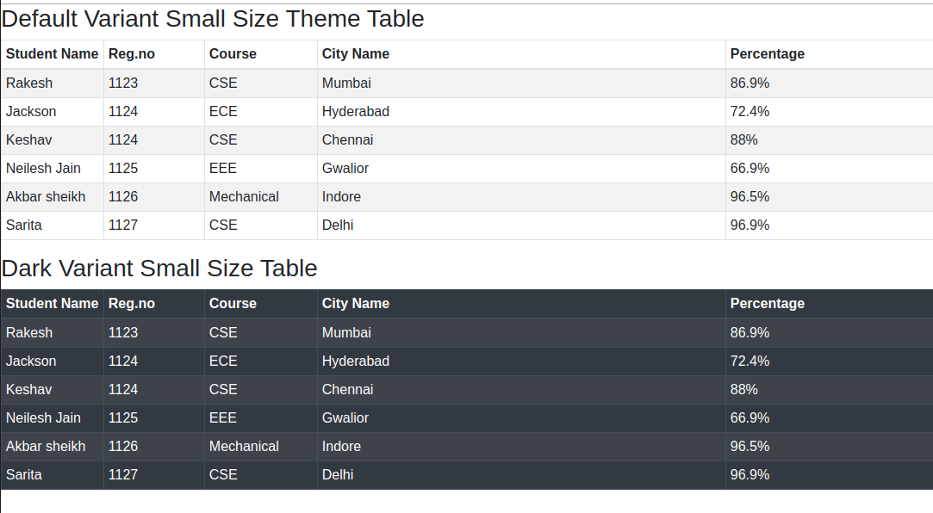
React-Bootstrap Cards Component
Introduction: React-Bootstrap is a front-end framework that was designed keeping react in mind. Bootstrap was re-built and revamped for React, hence it is known as React-Bootstrap. Cards are a type of section or containers which consists of information in a structured and organized way.
Creating React Application And Installing Module:
Step 1: Create a React application using the following command.
npx create-react-app foldername
Step 2: After creating your project folder i.e. foldername, move to it using the following command.
cd foldername
Step 3: After creating the ReactJS application, Install the required modules using the following command.
Properties: The Card component has many properties that we can use to organize data. In below table, the properties are explained
- Title: It acts as a title for the card.
- SubTitle: It acts as a subtitle for the mentioned title.
- Text: In this section, we will mention all the necessary data.
- Link: This property is used to add the links for our cards.
npm install react-bootstrap bootstrap
Project Structure: It will look like the following.
Project Structure
App.js: Now write down the following code in the App.js file. Here, App is our default component where we have written our code.
- Javascript
import Card from "react-bootstrap/Card";
import React from "react";

export default function App() {
return (
<>
<Card style={{ width: "22rem" }}>
<Card.Body>
<Card.Title style={{ color: "green" }}>GEEKSFORGEEKS</Card.Title>
<Card.Subtitle className="mb-2 text-muted">
One Stop For all CS subjects
</Card.Subtitle>
<Card.Text>
GeeksforGeeks provides a platform for all the students to study
about all the subjects in CSE.
</Card.Text>
<Card.Link href="#"> For Students</Card.Link>
</Card.Body>
</Card>
</>
);
}
Step to Run Application: Run the application using the following command from the root directory of the project:
npm start
Output: Now open your browser and go to http://localhost:3000/, you will see the following output.

React-Bootstrap ButtonGroup Component
React-Bootstrap is a front-end framework that was designed keeping react in mind. ButtonGroup Component provides a way to group a series of buttons together on a single line. We can use the following approach in ReactJS to use the react-bootstrap ButtonGroup Component.
ButtonGroup Props:
- role: It is an ARIA role that describes the button group.
- size: It is used to sets the size for all Buttons which are there in the group.
- toggle: It is used to display like button toggle group.
- vertical: It provides a way to make the set of buttons look vertically stacked.
- as: It can be used as a custom element type for this component.
- bsPrefix: It is an escape hatch for working with strongly customized bootstrap CSS.
ButtonToolbar Props:
- role: It is an ARIA role that describes the button toolbar.
- bsPrefix: It is an escape hatch for working with strongly customized bootstrap CSS.
Creating React Application And Installing Module:
- Step 1: Create a React application using the following command:
npx create-react-app foldername
- Step 2: After creating your project folder i.e. folder name, move to it using the following command:
cd foldername
- Step 3: After creating the ReactJS application, Install the required module using the following command:
- npm install react-bootstrap
npm install bootstrap
Project Structure: It will look like the following.
Project Structure
Example: Now write down the following code in the App.js file. Here, App is our default component where we have written our code.
App.js
import React from 'react';
import 'bootstrap/dist/css/bootstrap.css';
import ButtonGroup from 'react-bootstrap/ButtonGroup';
import Button from 'react-bootstrap/Button';

export default function App() {
return (
<div style={{ display: 'block',
width: 700,
padding: 30 }}>
<h4>React-Bootstrap ButtonGroup Component</h4>
<ButtonGroup aria-label="Basic example">
<Button variant="secondary">
Left Button
</Button>
<Button variant="primary">
Middle Button
</Button>
<Button variant="secondary">
Right Button
</Button>
</ButtonGroup>
</div>
);
}
Step to Run Application: Run the application using the following command from the root directory of the project:
npm start
Output: Now open your browser and go to http://localhost:3000/, you will see the following output:
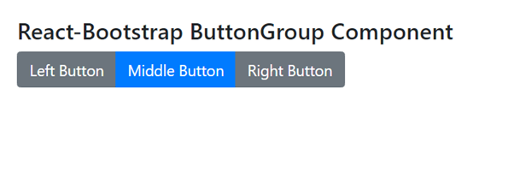
React-Bootstrap Tabs Component
React-Bootstrap is a front-end framework that was designed keeping react in mind. Tabs Component provides a way to make form dynamic tabbed interfaces. With the help of tabs, the user can switch between components present in given different tabs. We can use the following approach in ReactJS to use the react-bootstrap tabs Component.
Tabs Props:
- activeKey: It is used to mark the tab as active based on the matching event key.
- defaultActiveKey: It is used to indicate the default active key that is selected on start.
- id: It is the HTML id attribute required when no generateChildId prop is specified.
- mountOnEnter: It is used to mount tabs.
- onSelect: It is a callback function that is triggered when a tab is selected.
- transition: For all children <TabPane>, it is used to set a default animation strategy.
- unmountOnExit: It is used to unmount the tabs.
- variant: It is used to define the navigation style.
Tab Props:
- disabled: It is used to disable the component.
- eventKey: It is basically a unique identifier for the component.
- tabClassName: It is used to add the class name for the tab styling.
- title: It is used to indicate the title for the tab component.
TabContainer Props:
- activeKey: It is used for the eventKey of the current tab which is active.
- defaultActiveKey: It is used for the default eventKey for the tab.
- generateChildId: It is a function that is used to generate the unique id for child tab <TabPane>s and <NavItem>s on the basis of eventKey and type which is passed as a parameter to this function.
- id: It is the normal HTML id attribute for identification.
- mountOnEnter: It is used to wait until first “enter” transition to mount the tab.
- onSelect: It is a callback that is triggered when a tab is selected.
- transition: For all children, it is used to set a default animation strategy.
- unmountOnExit: It is used to unmount the tab.
TabContent Props:
- as: It can be used as a custom element type for this component.
- bsPrefix: It is an escape hatch for working with strongly customized bootstrap CSS.
TabPane Props:
- active: It is used to toggle the active state of the TabPane.
- aria-labelledby: It is used to pass the aria labeled attribute to TabPane.
- as: It can be used as a custom element type for this component.
- eventKey: It is used a key that associates TabPane with help of its controlling NavLink
- id: It is the normal HTML id attribute for identification.
- mountOnEnter: It is used to wait until first “enter” transition to mount the tab.
- onEnter: When animation is not false, it is used to transition the OnEnter callback.
- onEntered: When animation is not false, it is used to transition the OnEntered callback.
- onEntering: When animation is not false, it is used to transition the OnEntering callback.
- onExit: When animation is not false, it is used to transition the OnExit callback.
- onExited: When animation is not false, it is used to transition the OnExited callback.
- onExiting: When animation is not false, it is used to transition the OnExiting callback.
- transition: It is used to show the animation when hiding or showing the <TabPane>s
- unmountOnExit: It is used to unmount the tab.
- bsPrefix: It is an escape hatch for working with strongly customized bootstrap CSS.
Creating React Application And Installing Module:
- Step 1: Create a React application using the following command:
npx create-react-app foldername
- Step 2: After creating your project folder i.e. foldername, move to it using the following command:
cd foldername
- Step 3: After creating the ReactJS application, Install the required module using the following command:
- npm install react-bootstrap
npm install bootstrap
Project Structure: It will look like the following.
Project Structure
Example: Now write down the following code in the App.js file. Here, App is our default component where we have written our code.
App.js
import React from 'react';
import 'bootstrap/dist/css/bootstrap.css';
import Tabs from 'react-bootstrap/Tabs';
import Tab from 'react-bootstrap/Tab';

export default function App() {
return (
<div style={{ display: 'block', width: 700, padding: 30 }}>
<h4>React-Bootstrap Tab Component</h4>
<Tabs defaultActiveKey="second">
<Tab eventKey="first" title="Dashboard">
Hii, I am 1st tab content
</Tab>
<Tab eventKey="second" title="Setting">
Hii, I am 2nd tab content
</Tab>
<Tab eventKey="third" title="Aboutus">
Hii, I am 3rd tab content
</Tab>
</Tabs>
</div>
);
}
Step to Run Application: Run the application using the following command from the root directory of the project:
npm start
Output: Now open your browser and go to http://localhost:3000/, you will see the following output:
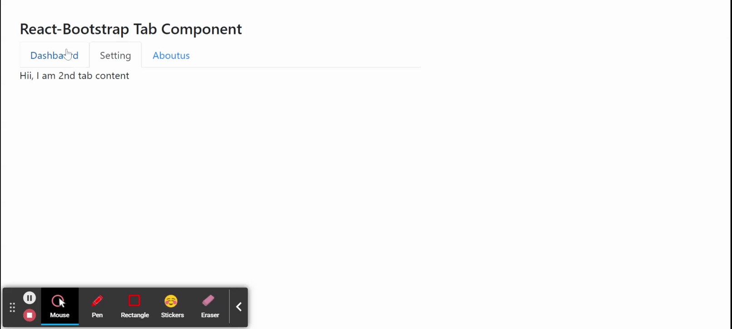

React-Bootstrap Pagination Component
React-Bootstrap is a front-end framework that was designed keeping react in mind. Pagination Component provides a way for users to switch between pages easily. It is basically a set of presentational components for providing a better UI experience to the user. We can use the following approach in ReactJS to use the react-bootstrap Pagination Component.
Pagination Props:
- size: It is used to define the size of all PageItems.
- bsPrefix: It is an escape hatch for working with strongly customized bootstrap CSS.
PageItem Props:
- active: It is used to style the Page items as for the active state.
- activeLabel: It is used to indicate the active state by an accessible label.
- disabled: It is used to disable the page item component.
- href: t is used to provide the href attribute for this element.
- onClick: It is a callback function that is triggered when this component is clicked.
Creating React Application And Installing Module:
- Step 1: Create a React application using the following command:
npx create-react-app foldername
- Step 2: After creating your project folder i.e. foldername, move to it using the following command:
cd foldername
- Step 3: After creating the ReactJS application, Install the required module using the following command:
- npm install react-bootstrap
npm install bootstrap
Project Structure: It will look like the following.
Project Structure
Example: Now write down the following code in the App.js file. Here, App is our default component where we have written our code.
App.js
import React from 'react';
import 'bootstrap/dist/css/bootstrap.css';
import Pagination from 'react-bootstrap/Pagination';

export default function App() {
return (
<div style={{ display: 'block', width: 700, padding: 30 }}>
<h4>React-Bootstrap Pagination Component</h4>
<Pagination>
<Pagination.Prev />
<Pagination.Ellipsis />
<Pagination.Item>{3}</Pagination.Item>
<Pagination.Item>{4}</Pagination.Item>
<Pagination.Item>{5}</Pagination.Item>
<Pagination.Ellipsis />
<Pagination.Next />
</Pagination>
</div>
);
}
Step to Run Application: Run the application using the following command from the root directory of the project:
npm start
Output: Now open your browser and go to http://localhost:3000/, you will see the following output:
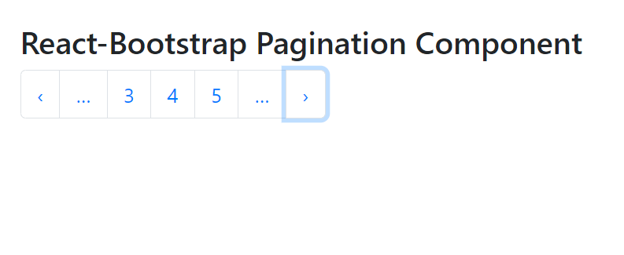

React-Bootstrap Dropdown Component
React-Bootstrap is a front-end framework that was designed keeping react in mind. Dropdown Component provides a way to displaying lists of links or more actions within a menu when clicked over it. We can use the following approach in ReactJS to use the react-bootstrap Dropdown Component.
Dropdown Props:
- alignRight: It is used to align the menu to the right side of the Dropdown toggle.
- as: It can be used as a custom element type for this component.
- drop: It is used to determine the location and direction of the Menu in relation to its toggle.
- flip: It is used to flip the dropdown in case of overlapping on the reference element.
- focusFirstItemOnShow: When the dropdown is opened, it is used to control the focus behavior for it.
- navbar: It is the attribute that is by default false and indicates whether dropdown is navbar related or not.
- onSelect: It is a callback function that is triggered when a menu item is selected.
- onToggle: It is used to trigger a callback when the visibility of the dropdown needs to be changed.
- show: It is used to indicate whether the dropdown is visible or not.
- bsPrefix: It is an escape hatch for working with strongly customized bootstrap CSS.
SplitButton Props:
- disabled: It is used to disable the button.
- href: It is used to pass the href attribute to the underlying non-toggle button.
- id: It is the general HTML id attribute for the toggle button.
- menuAlign: It is used to responsively align the dropdown menu.
- menuRole: It is used for the ARIA accessible role applied which is applied to the menu component.
- onClick: It is the callback function that is passed as a handler for the non-toggle button.
- renderMenuOnMount: It is used to indicate whether to render the dropdown menu before the first time it is shown in the DOM.
- rootCloseEvent: It is used to close the component when which event is triggered outside this component.
- size: It denotes the size of the component.
- target: For the non-toggle Button, it is an anchor target passed to it.
- title: It is used to define the content of non-toggle Button.
- toggleLabel: For the toggle button, it is the accessible label.
- type: It is used to pass the type for the non-toggle button.
- variant: It is used to indicate the style variant for it.
- bsPrefix: It is an escape hatch for working with strongly customized bootstrap CSS.
Dropdown.Toggle Props:
- as: It can be used as a custom element type for this component.
- childBsPrefix: It is used for the DropdownButton to pass through to the underlying button or whatever from it.
- eventKey: It is used to uniquely identify the dropdown toggle component.
- id: It is used to pass the HTML id attribute to this element.
- split: It is used to pass the split attribute to this element.
- bsPrefix: It is an escape hatch for working with strongly customized bootstrap CSS.
Dropdown.Menu Props:
- align: It is used for the dropdown menu to align it to the specified side of the container.
- alignRight: It is used for the dropdown menu to align it to the right side of the container.
- as: It can be used as a custom element type for this component.
- flip: It is used to flip the dropdown to its opposite placement.
- onSelect: It is a callback function that is triggered when the menu item is selected.
- popperConfig: It is used to pass the set of popper options to the popper directly.
- renderOnMount: It is used to indicate whether to render the dropdown menu before the first time it is shown in the DOM.
- rootCloseEvent: It is used to close the component when which event is triggered outside this component.
- show: It is used to indicate whether the dropdown menu is visible or not.
- bsPrefix: It is an escape hatch for working with strongly customized bootstrap CSS.
Dropdown.Item Props:
- active: It can be used to mark the menu item as active.
- as: It can be used as a custom element type for this component.
- disabled: It is used to make the menu item disabled.
- eventKey: It is used to uniquely identify the selected menu item.
- href: It is used to pass the href attribute to this element.
- onClick: It is a callback function that is triggered when the menu item is clicked.
- onSelect: It is a callback function that is triggered when the menu item is selected.
- bsPrefix: It is an escape hatch for working with strongly customized bootstrap CSS.
Dropdown.Header Props:
- as: It can be used as a custom element type for this component.
- bsPrefix: It is an escape hatch for working with strongly customized bootstrap CSS.
Dropdown.Divider Props:
- as: It can be used as a custom element type for this component.
- bsPrefix: It is an escape hatch for working with strongly customized bootstrap CSS.
Creating React Application And Installing Module:
- Step 1: Create a React application using the following command:
npx create-react-app foldername
- Step 2: After creating your project folder i.e. foldername, move to it using the following command:
cd foldername
- Step 3: After creating the ReactJS application, Install the required module using the following command:
- npm install react-bootstrap
npm install bootstrap
Project Structure: It will look like the following.
Project Structure
Example: Now write down the following code in the App.js file. Here, App is our default component where we have written our code.
- App.js
import React from 'react';
import 'bootstrap/dist/css/bootstrap.css';
import Dropdown from 'react-bootstrap/Dropdown';

export default function App() {
return (
<div style={{ display: 'block',
width: 700,
padding: 30 }}>
<h4>React-Bootstrap Dropdown Component</h4>
<Dropdown>
<Dropdown.Toggle variant="success">
Open Menu
</Dropdown.Toggle>
<Dropdown.Menu>
<Dropdown.Item href="#">
Home Page
</Dropdown.Item>
<Dropdown.Item href="#">
Settings
</Dropdown.Item>
<Dropdown.Item href="#">
Logout
</Dropdown.Item>
</Dropdown.Menu>
</Dropdown>
</div>
);
}
Step to Run Application: Run the application using the following command from the root directory of the project:
npm start
Output: Now open your browser and go to http://localhost:3000/, you will see the following output:
